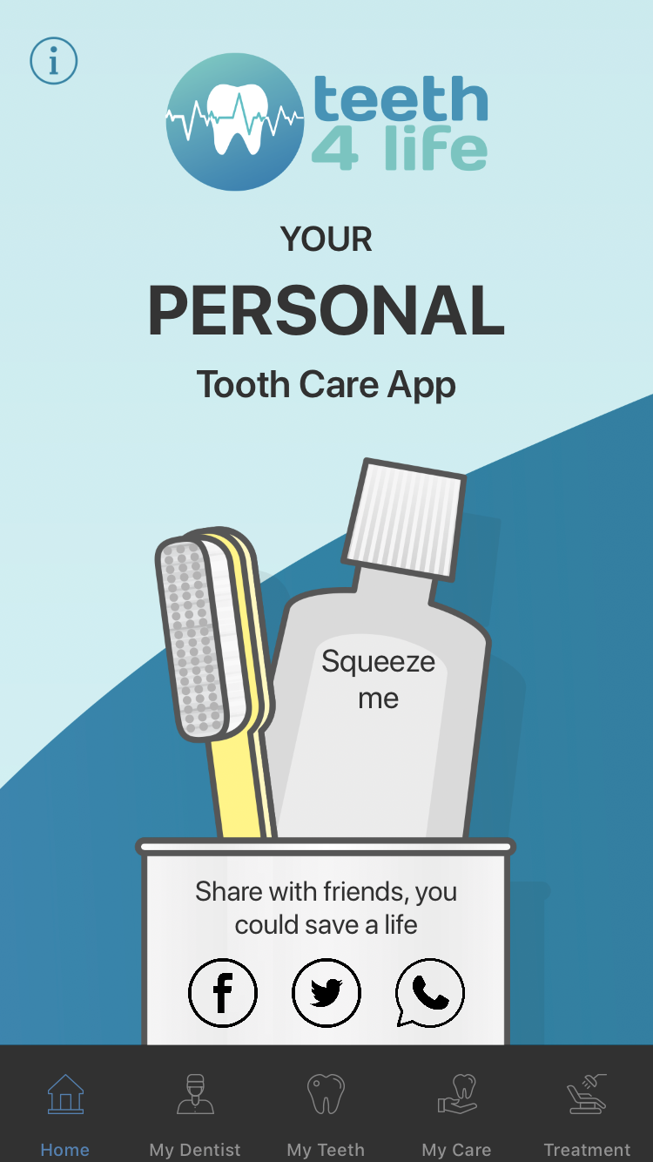
STAGE 2 RECEPTION AREA MARKETING
DOWNLOAD OUR DENTAL HEALTH APP TO SUPPORT OUR DENTAL HEALTH ADVICE AND HELP REDUCE YOUR TIME AND MONEY SPENT IN OUR DENTAL CHAIR
IF YOU HAVE VIDEO SCREEN WE HAVE 2 MIN RECEPTION VIDEO ON CARE4TEEETH.CO.UK
AND RANGE OF POSTERS

https://youtu.be/W7MASZJzzro

