STAGE 3 IN SURGERY

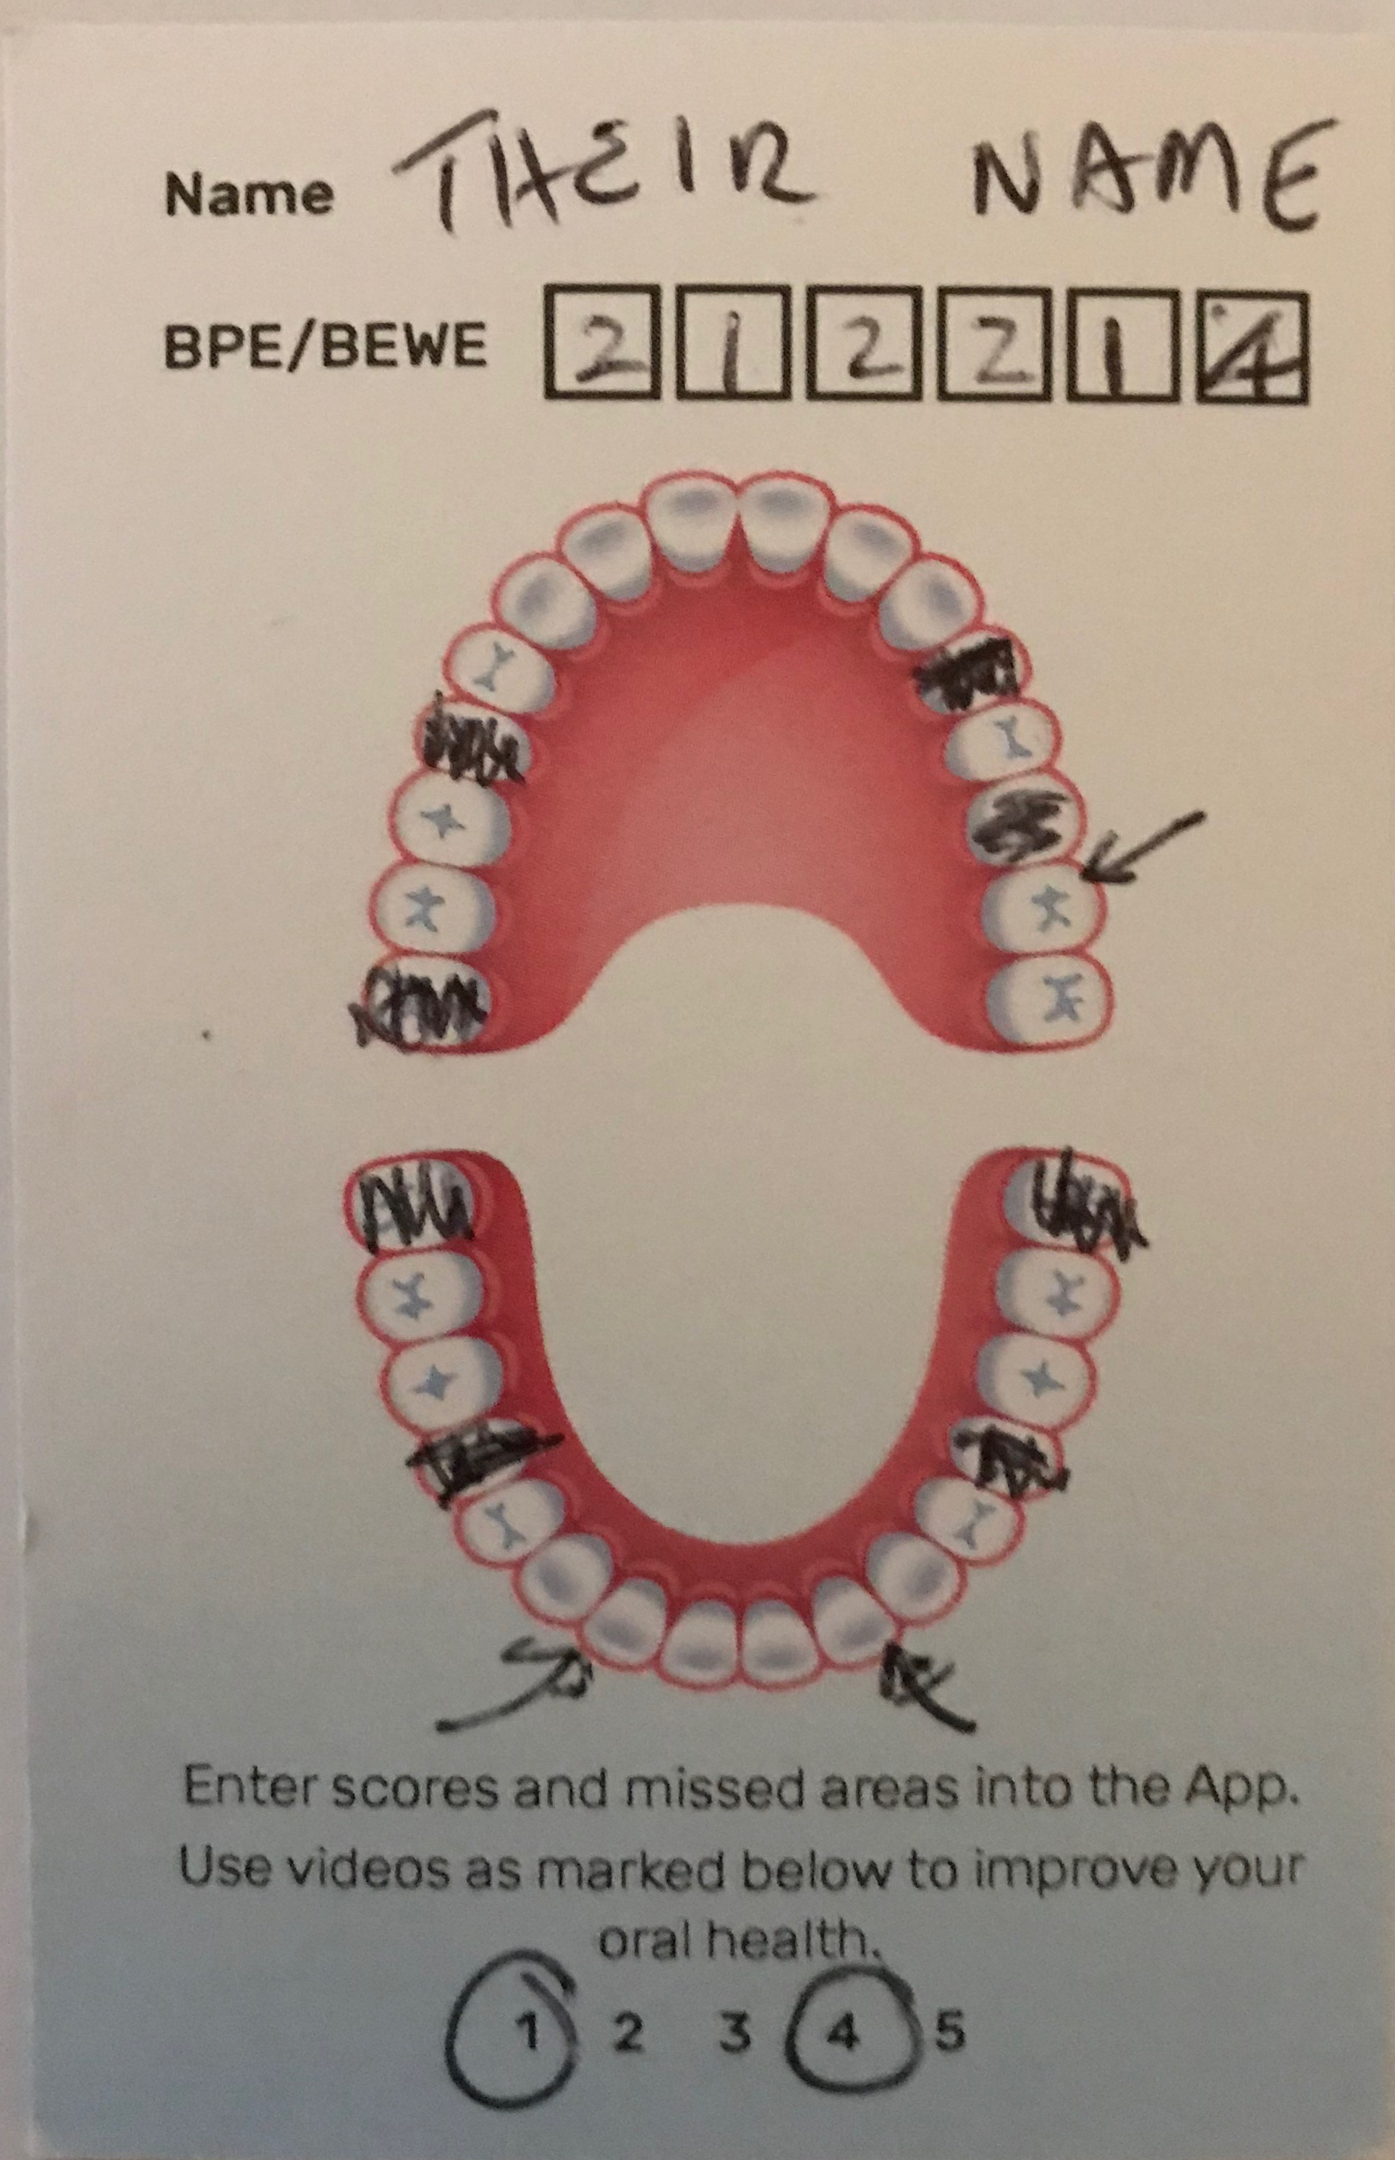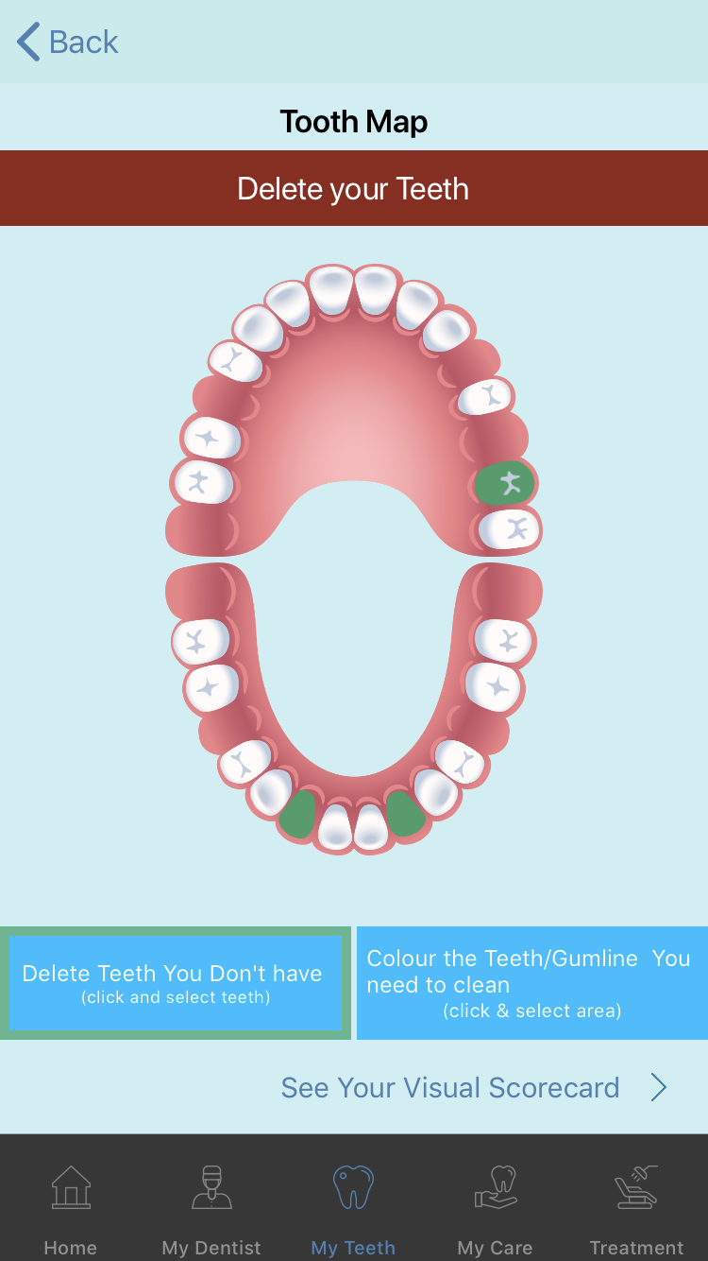

FILL IN CARD WITH PATIENTS DETAILS ON THE BUSINESS CARD FRONT TO PERSONALISE THE APP FOR THEMSELVES



MARKET YOURSELF ON THE REAR OF THE CARD WITH YOUR DETAILS , PLUS APP DETAILS OR YOUR PROMOTIONS